

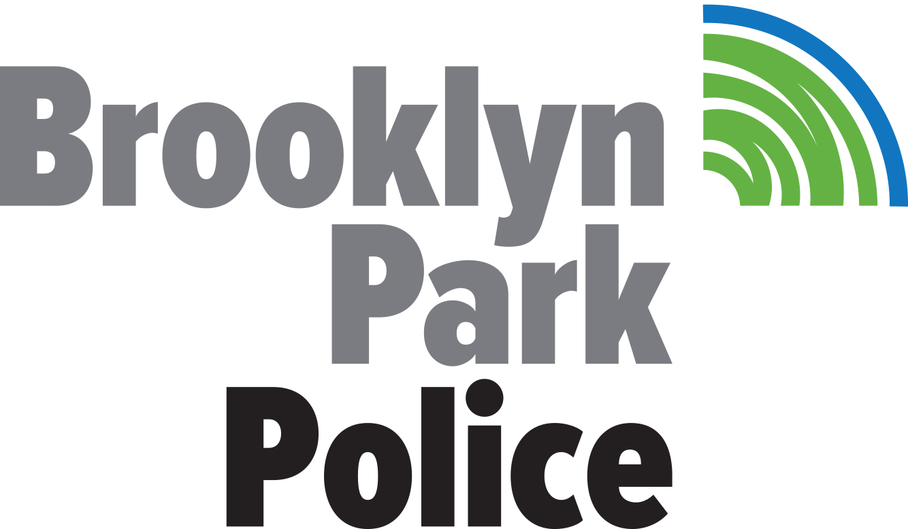


For Immediate Release Contact Dan Hendrickson, BBB: 651-695-2463
December 18, 2017

Protect yourself from credit card skimming

Burnsville, Minnesota – December 19, 2017 – Even if you’re choosy about which gas stations you frequent, you can still become a victim of financial thieves that place seamless devices on machines to steal – or ‘skim’ - sensitive financial information. Skimming is a growing problem, and Better Business Bureau ® of Minnesota and North Dakota (BBB), the Minnesota Department of Commerce and several other local and federal law enforcement agencies say consumers need to remain vigilant to steer clear of this scam which can also lead to identity theft.

In recent years, thieves have increasingly targeted gas pumps to steal credit card data. Skimming devices are placed inside the pump and are undetectable from the outside. Credit card information can now even be obtained from the skimming device via Bluetooth technology so thieves don’t have to go back to the pump to retrieve stolen card numbers. Many gas stations are taking measures to secure their pumps via tamper-resistant security tape and visual inspections, but to avoid having your financial information stolen, pay inside rather than at the pump. Minnesota’s Department of Commerce is also taking steps to tackle this problem.

“To protect consumers, Minnesota Department of Commerce’s Weights & Measures inspectors are on the lookout for skimmers during their regular inspections of gas pumps for accuracy, safety and fuel quality,” said Commerce Commissioner Jessica Looman. “Consumers can protect their money by being aware of signs of tampering and reporting suspicious activity to the station and the Commerce Department.”

To avoid becoming a victim of credit card skimmers:

Give it a wiggle – Skimming devices are often false panels attached to the credit card reader – where you swipe your card. Inspect debit and credit terminals closely. If anything looks damaged or unusual, give it a wiggle. Also watch out for new or suspiciously placed cameras and unusual signage. Don’t hesitate to walk away and if something doesn’t feel right.

Pay inside or pay with cash – Paying inside at gas stations reduces your risk of credit card fraud greatly, and paying with cash is an even safer approach.

See something, say something -- If you notice any suspicious activity (especially someone who is not a station employee or an inspector who is opening up a pump), alert the station attendant.

Keep an eye on your statements – The most vigilant person can still fall victim to skimming, and it’s important to always keep a close eye on your accounts – particularly the itemized breakdown of monthly charges – so that you can report any suspicious activity on your account.

Report fraud immediately – Report any fraudulent activity to your bank or credit card provider as soon as you discover it. Paying with a credit card instead of a debit card, because they offer great protections. Consumers who think that they’ve been victims of skimming should visit IdentityTheft.gov to report identity theft and develop a recovery plan

“Just as it’s important to know what to watch out for as far as these skimming devices, it’s equally important to know what to do if you’ve fallen victim,” said Susan Adams Loyd, President and CEO of BBB of Minnesota and North Dakota.

The FBI investigates a wide variety of credit card fraud schemes to include Internet-facilitated criminal activity. If you believe you’ve been a victim of an online fraud scheme, the FBI Internet Crime Complaint Center is a reliable and convenient reporting mechanism to submit information using the following website: www.ic3.gov/. Consumers can also file complaints with the FTC (877-FTC-HELP; ftc.gov)

If you notice any suspicious activity (especially someone who is not a station employee or an inspector opening up a pump), alert the station attendant or call the MN Department of Commerce’s Weight & Measures Division at 651-539-1555.

These tips were created with input and assistance from: Minnesota Department of Commerce; the FBI and FTC; Apple Valley Police Department; and Brooklyn Park Police Department

The mission of Better Business Bureau is to be the leader in building marketplace trust by promoting, through self-regulation, the highest standards of business ethics and conduct, and to instill confidence in responsible businesses through programs of education and action that inform, assist and protect the general public. Our hours of operation are 8 a.m. to 5 p.m. Monday through Friday. Contact BBB at bbb.org or 651-699-1111, toll-free at 800-646-6222.

# # #

